New production labels layout (Consumer template)

NEW Fit for food logo:

Is the product fit for food? – If not, this logo will not be shown

RPC Superfos Art. Code

032510106.03287.03

NEW Factory ID letter + batch no.

R= Randers

11= Production year

61100 = Production order

NEW GTIN

57056619 01450 0 = RPC Superfos art. Code 032510106.03287.03

NEW barcode with three types of information:

(02): GTIN (EAN code)

(37): Quantity

(10): Batch No.

(00) SSCC barcode

**S**erial **S**hipping **C**ontainer **C**ode

Unique barcode which identifies the produced unit on pal/box level

Pallet/Box number within batch +

The total number of pallets/boxes in the batch

Quantity per box or pallet.

Will always match the correct quantity even though the pallet is a part pallet

UN Information Line

Will be filled in if the product is UN approved

Customer specific data: E.g. the customer’s internal article. no.

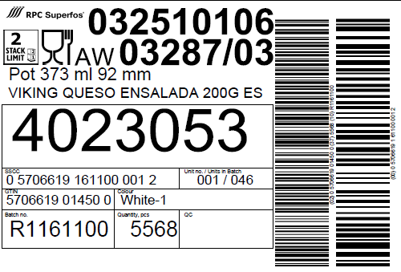

**Both barcodes are printed according to the GS1-128 barcode specification**

NEW Stackability logo:

Indicates many pallets can be stacked upon each other in the warehouse

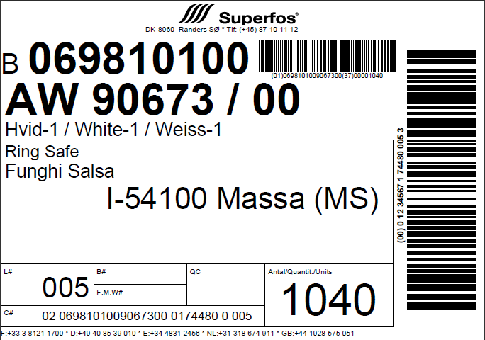

List of Factory ID’s

|  |  |  |  |  |  |  |  |  |  |  |  |  |  |  |  |  |  |
| --- | --- | --- | --- | --- | --- | --- | --- | --- | --- | --- | --- | --- | --- | --- | --- | --- | --- |
| |  |  | | --- | --- | | C | Besancon | | E | Pamplona | | L | La Genete | | N | Mullsjö | | O | Lubien | | Q | Tenhult | | R | Randers | | S | Wetteren | |  |
|  |  |
|  |  |
|  |  |
|  |  |
|  |  |
|  |  |
|  |  |

Old Production label layout

New production labels layout (Industrial template)

NEW Fit for food logo:

Is the product fit for food? – If not, this logo will not be shown

NEW Stackability logo:

Indicates how many pallets can be stacked upon each other in the warehouse

RPC Superfos Art. Code

610910176 08632.00

Customer specific data: E.g. the customer’s internal article. no.

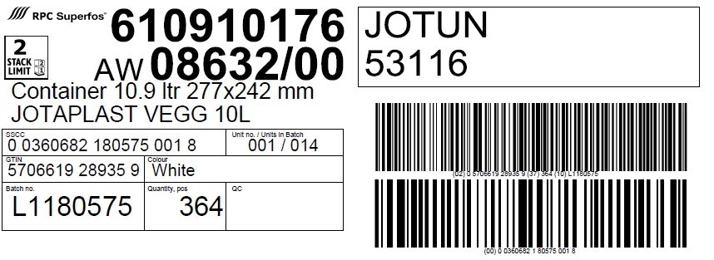

NEW GTIN

5706619 28935 9 = RPC Superfos Art. Code 610910176 08632.00

Pallet/Box number +

The total number of pallets/boxes in the batch

Quantity per box or pallet.

Will always match the correct quantity even though the pallet is a part pallet

UN Information Line

Will be filled in if the product is UN approved

NEW barcode with three types of information:

(02): GTIN (EAN code)

(37): Quantity

(10): Batch No.

(00) SSCC barcode

Serial Shipping Container Code

Unique barcode which identifies the produced unit on pal/box level

NEW Factory ID letter + batch no.

L= La Genete

11= Production year

80575 = Production order

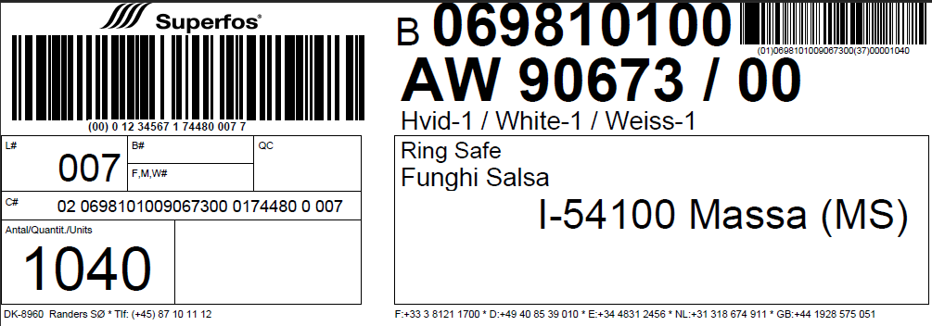

**Both barcodes are printed according to the GS1-128 barcode specification**

List of Factory ID’s

|  |  |  |  |  |  |  |  |  |  |  |  |  |  |  |  |  |  |
| --- | --- | --- | --- | --- | --- | --- | --- | --- | --- | --- | --- | --- | --- | --- | --- | --- | --- |
| |  |  | | --- | --- | | C | Besancon | | E | Pamplona | | L | La Genete | | N | Mullsjö | | O | Lubien | | Q | Tenhult | | R | Randers | | S | Wetteren | |  |
|  |  |
|  |  |
|  |  |
|  |  |
|  |  |
|  |  |
|  |  |

Old production label layout